**Problem:**

A real estate economist collects information on 1000 house price sales from two similar

neighborhoods, one called “University Town” bordering a large state university, and another a

neighborhood about three miles from the university. He specifies the following regression

equation:

y = β0 + β1x1 + δ2D2 + γ(D2 ∗ x1) + β3 x3 + δ4D4 + δ5D5 + ε

where

y = house prices in $1000

x1 = the number of hundreds of square feet of living area

D2 ={

1 house near university

0 otherwise

x3 = age of the house (in years)

D4 ={

1 house has pool

0 otherwise

D5 ={

1 if fireplace is present

0 otherwise

Discuss the effect of these variables on house prices

**Solution**

**###################################### Read the dataset##########################**

**df <- read.table("C:/Users/Asus/Downloads/housing.txt", header = TRUE)**

**head(df, n=10)**

P S A Ut Pol Fp

1 205.452 23.46 6 0 0 1

2 185.328 20.03 5 0 0 1

3 248.422 27.77 6 0 0 0

4 154.690 20.17 1 0 0 0

5 221.801 26.45 0 0 0 1

6 199.119 21.56 6 0 0 1

7 272.134 29.91 9 0 0 1

8 250.631 27.98 0 0 0 1

9 197.240 24.80 0 0 1 0

10 235.755 27.50 0 0 0 0

**summary(df)**

P S A Ut

Min. :134.3 Min. :20.03 Min. : 0.000 Min. :0.000

1st Qu.:215.6 1st Qu.:22.83 1st Qu.: 3.000 1st Qu.:0.000

Median :245.8 Median :25.36 Median : 6.000 Median :1.000

Mean :247.7 Mean :25.21 Mean : 9.392 Mean :0.519

3rd Qu.:278.3 3rd Qu.:27.75 3rd Qu.:13.000 3rd Qu.:1.000

Max. :345.2 Max. :30.00 Max. :60.000 Max. :1.000

Pol Fp

Min. :0.000 Min. :0.000

1st Qu.:0.000 1st Qu.:0.000

Median :0.000 Median :1.000

Mean :0.204 Mean :0.518

3rd Qu.:0.000 3rd Qu.:1.000

Max. :1.000 Max. :1.000

**Interpretation:** Here from this summery, it is noticeable that for the feature Age the max value is significantly larger than all the measure of central tendency.

**#################################### Histogram ######################**

**par(mfrow = c(2, 3))**

**for (col in colnames(df)) {**

**hist(df[[col]], main = col, xlab = col, ylab = "Frequency")**

**}**

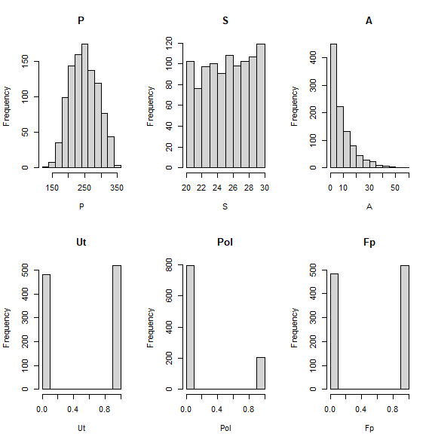

Firstly, the histogram for the feature price is in normal/gausian distribution.it depicts the average pricing for houses is 250.secondly the size of those houses are almost same.thirdly , the shape of the feature Age is positively skewed.as it gives us the information that only a few houses are very old which is nearly 60 years. It also shows that the urbanization started in that town within 10 years.

**################################### Boxplot ##########################**

**par(mfrow = c(2, 3)) # Adjust the numbers to arrange the boxplots in the desired layout**

**for (col in colnames(df)) {**

**boxplot(df[[col]], main = col, xlab = col, ylab = "Value")**

**}**

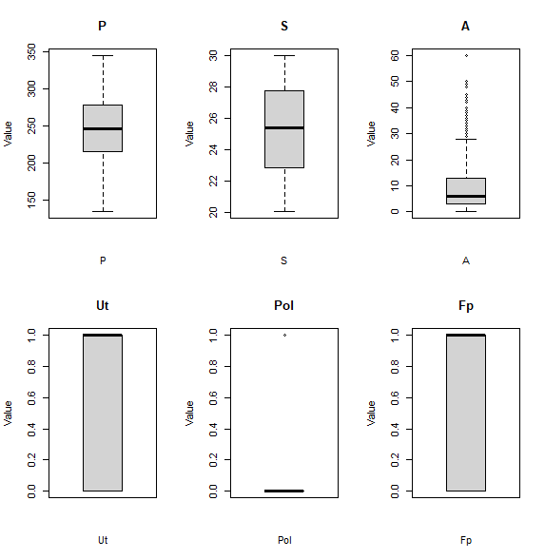

From this boxplot we see that for the feature Age the value 60 probably be detected as outlier.but all other features are free from outlier.

**################################## correlation matrix ##################**

**cor_matrix <- cor(df)**

**print(cor_matrix)**

**################################# relation between price and all other variables #########**

**par(mfrow = c(2, 3)) # Adjust the numbers to arrange the plots in the desired layout**

**for (col in colnames(df)[-which(colnames(df) == "P")]) {**

**plot(df[[col]], df$P, main = paste("Scatter plot:", col), xlab = col, ylab = "House Price")**

**}**

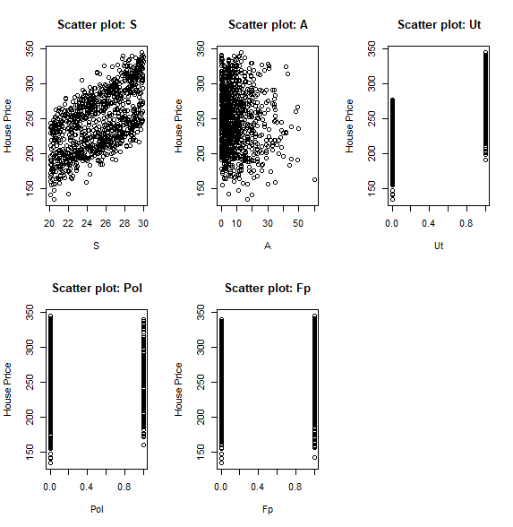

From this plot we may interpret that there is a linear relationship between House price and the area of houses.on the other hand, the price is high for those houses which are built within nearly 10 years which has the intention to decrese with house maturity.for the most matured house (60 years) the price is noticeably low.

It is also seen that the price is high if the house is near the university .in contrast for other two feature pool and fireplace price is constant, that means price doesn’t matter wheather there is a pool and fireplace or not.

**######################################## MODEL ######################**

**library(car)**

**ml1=lm(P~S+Ut+I(S*Ut)+A+Pol+Fp+I(Pol*Fp),data=df)**

**ml1**

Call:

lm(formula = P ~ S + Ut + I(S * Ut) + A + Pol + Fp + I(Pol *

Fp), data = df)

Coefficients:

(Intercept) S Ut I(S * Ut) A

24.2414 7.6163 27.4700 1.2985 -0.1894

Pol Fp I(Pol * Fp)

5.0623 1.9341 -1.4093

**library(car)**

**vif_values<-vif(ml1)**

**vif_values**

S Ut I(S * Ut) A Pol Fp

2.208352 76.397898 78.041544 1.004610 1.952888 1.270127

I(Pol * Fp)

2.167511

Based on the provided **Variable Infletion Factor(VIF)** values for the variable , the VIF value of the Ut is 76.397898 which means the high level of correlation with other variables in the model.it potentially indicating multicollinearity.

Similarly, interection between living area and proximity to university the VIF value is 78.041544. It also indicate the high level of multicollinearity with other variable in the model.

**plot(ml1)**

**ssrf=sum(resid(ml1)^2)**

**ssrf**

230104.2

This represents the sum squared residual of the model is 230104.2

**ml2=lm(P~S+A,data=df)**

**summary(ml2)**

lm(formula = P ~ S + A, data = df)

Residuals:

Min 1Q Median 3Q Max

-79.017 -30.271 3.693 30.292 72.867

Coefficients:

Estimate Std. Error t value Pr(>|t|)

(Intercept) 34.2309 9.4052 3.64 0.000287 ***

S 8.5723 0.3671 23.35 < 2e-16 ***

A -0.2853 0.1136 -2.51 0.012228 *

---

Signif. codes: 0 ‘***’ 0.001 ‘**’ 0.01 ‘*’ 0.05 ‘.’ 0.1 ‘ ’ 1

Residual standard error: 33.85 on 997 degrees of freedom

Multiple R-squared: 0.3577, Adjusted R-squared: 0.3564

F-statistic: 277.6 on 2 and 997 DF, p-value: < 2.2e-16

The intercept 34.2309 represents the estimated house price when both the area and Age are 0.

Coeff of **S (8.8523**) indicates that for every additional unit increase in the living area the estimated house price increase by 8.5723.so an increase in the area is associated with higher estimated house price.

In contrast, Coeff of **A (-0.2853)** indicates that for every additional year of age of the house, the estimated house price decrease by 0.2853.assumming all other variables in the model is constant. This means that older houses tend to have lower estimated price.

all coefficients (Intercept, S, and A) have p-values less than 0.05, indicating that they are statistically significant at a 5% significance level.

The Intercept and S has extremely low p-values (< 0.001), indicating highly significant relationships with house prices. The coefficient for A also has a relatively low p-value (0.012), suggesting a statistically significant relationship, although it is less significant compared to the Intercept and S.

The F-statistic of 277.6 with a very low p-value (< 2.2e-16) indicates that the overall model is statistically significant

**ssrf2=sum(resid(ml2)^2)**

**ssrf2**

[1] 1142293

**ml3=lm(P~S+Ut+I(S*Ut)+A+Pol+Fp,data=df)**

**summary(ml3)**

Call:

lm(formula = P ~ S + Ut + I(S * Ut) + A + Pol + Fp, data = df)

Residuals:

Min 1Q Median 3Q Max

-50.289 -10.141 0.148 10.565 44.783

Coefficients:

Estimate Std. Error t value Pr(>|t|)

(Intercept) 24.5000 6.1917 3.957 8.13e-05 ***

S 7.6122 0.2452 31.048 < 2e-16 ***

Ut 27.4530 8.4226 3.259 0.001154 **

I(S * Ut) 1.2994 0.3321 3.913 9.72e-05 ***

A -0.1901 0.0512 -3.712 0.000217 ***

Pol 4.3772 1.1967 3.658 0.000268 ***

Fp 1.6492 0.9720 1.697 0.090056 .

---

Signif. codes: 0 ‘***’ 0.001 ‘**’ 0.01 ‘*’ 0.05 ‘.’ 0.1 ‘ ’ 1

Residual standard error: 15.23 on 993 degrees of freedom

Multiple R-squared: 0.8706, Adjusted R-squared: 0.8698

F-statistic: 1113 on 6 and 993 DF, p-value: < 2.2e-16

The multiple R-squared value of 0.8706 indicates that approximately 87.06% of the variability in house prices can be explained by the independent variables.

The F-statistic of 1113 with a very low p-value (< 2.2e-16) suggests that the overall model is statistically significant

The residual standard error (15.23) represents the estimate of the standard deviation of the errors or residuals

**Conclusion:**

Overall, this project suggests that factors such as the square footage of living area, proximity to the university, age of the house, and the presence of a pool are important determinants of house prices.from these variables only the age(A) of he house has negative significance. Understanding these variables can help buyers, sellers, and real estate professionals make informed decisions regarding pricing and investment strategies